**Zxcvzxcvzxcvzxcvzxcvzxcvxzcv**

Dependencies

Flight Num

Time of Departure

Time of Arrival

Flight Date

Customer Num

Customer Name

Aircraft Serial

Aircraft Type

Aircraft Desc

Aircraft Capacity

Aircraft Range

Transitive Dependencies

Partial Dependencies

Dependencies

Customer Num

Aircraft Serial

Aircraft Type

Table Name: Aircraft

Aircraft Type

Descriptio-n

Capacity

Range

Table Name: Aircraft_Type

Table Name: Booking

Flight Num

TOD

TOA

Flight Date

Aircraft Serial

Table Name: Sched_Flight

Customer Num

Customer Name

Table Name: Customer

Michael Franklin

ITSE 2309-007  
Course Project  
Dependency Diagrams  
Pg 1

Flight Num

Flight Date

State Code

City Name

City Code

Airport Name

Michael Franklin

ITSE 2309-007  
Course Project  
Dependency Diagrams  
Pg 2

Dependencies

Airport Code

Transitive Dependencies

Partial Dependencies

City Code

City Name

State Code

Table Name: City

Airport Code

Airport Name

City Code

Table Name: Airport

Flight Num

Dprt Airprt Code

Ariv Airprt Code

Table Name: Flight

Michael Franklin

ITSE 2309-007  
Course Project  
ER Diagram  
Relational Schema

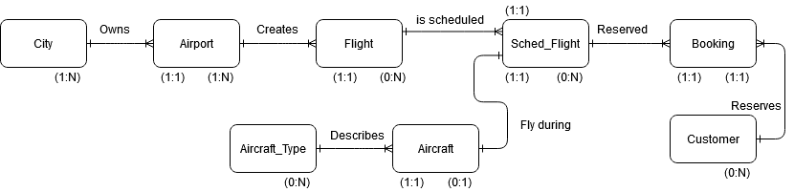

**City Table  
PK  
City_Code  
  
Customer Table  
PK  
Customer_Num**

**Aircraft_Type Table  
PK  
Aircraft_Type**

**Aircraft Table  
PK  
Aircraft_Serial  
FK  
Aircraft_Type**

**Airport Table  
PK  
Airport_Code**

**FK  
City_Code**

**Flight Table  
PK  
Flight_Num  
FK  
Ariv_Air_Code**

**FK  
Dprt_Air_Code**

**Sched_Flight Table  
PK  
Flight_Num  
Flight_Date  
FK  
Flight_Num  
FK  
Aircraft_Serial**

**Booking Table  
PK  
Flight_Num  
Flight_Date  
Customer_Num  
FK  
Flight_Num  
Flight_Date  
FK  
Customer_Num**